Requirement Analysis: Technology Stack

D) Technology Stack

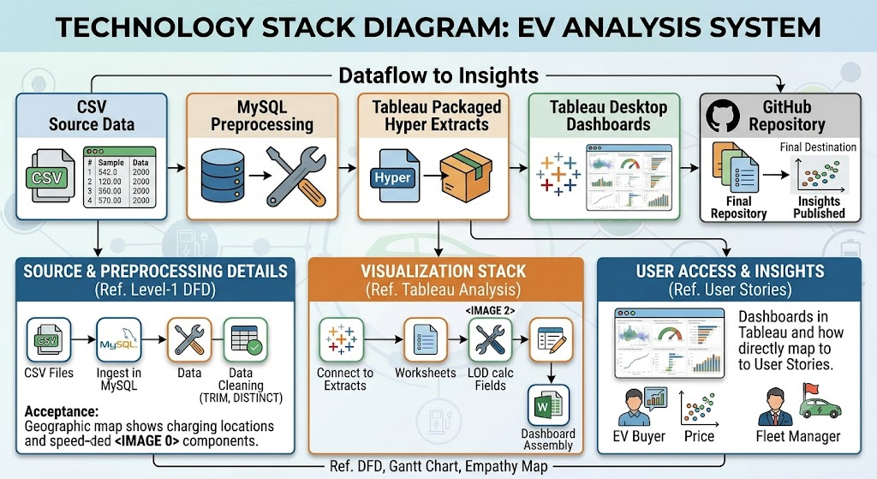Development Stack Visual Diagram
Layer | Technology Used | Purpose
Database | MySQL / MySQL Workbench | Data ingestion, validation, trimming, and clean export
Analytics | Tableau Desktop / Public | Creating calculated fields, worksheets, maps, and dashboard story
Storage | CSV Files | Raw and processed flat file datasets for portability
Workbook | Packaged Tableau Workbook (.twbx) | Packaging workbook xml together with Hyper extracts
Version Control | GitHub | Publishing project code, SQL scripts, and documentation reports

Technology Stack Reference
